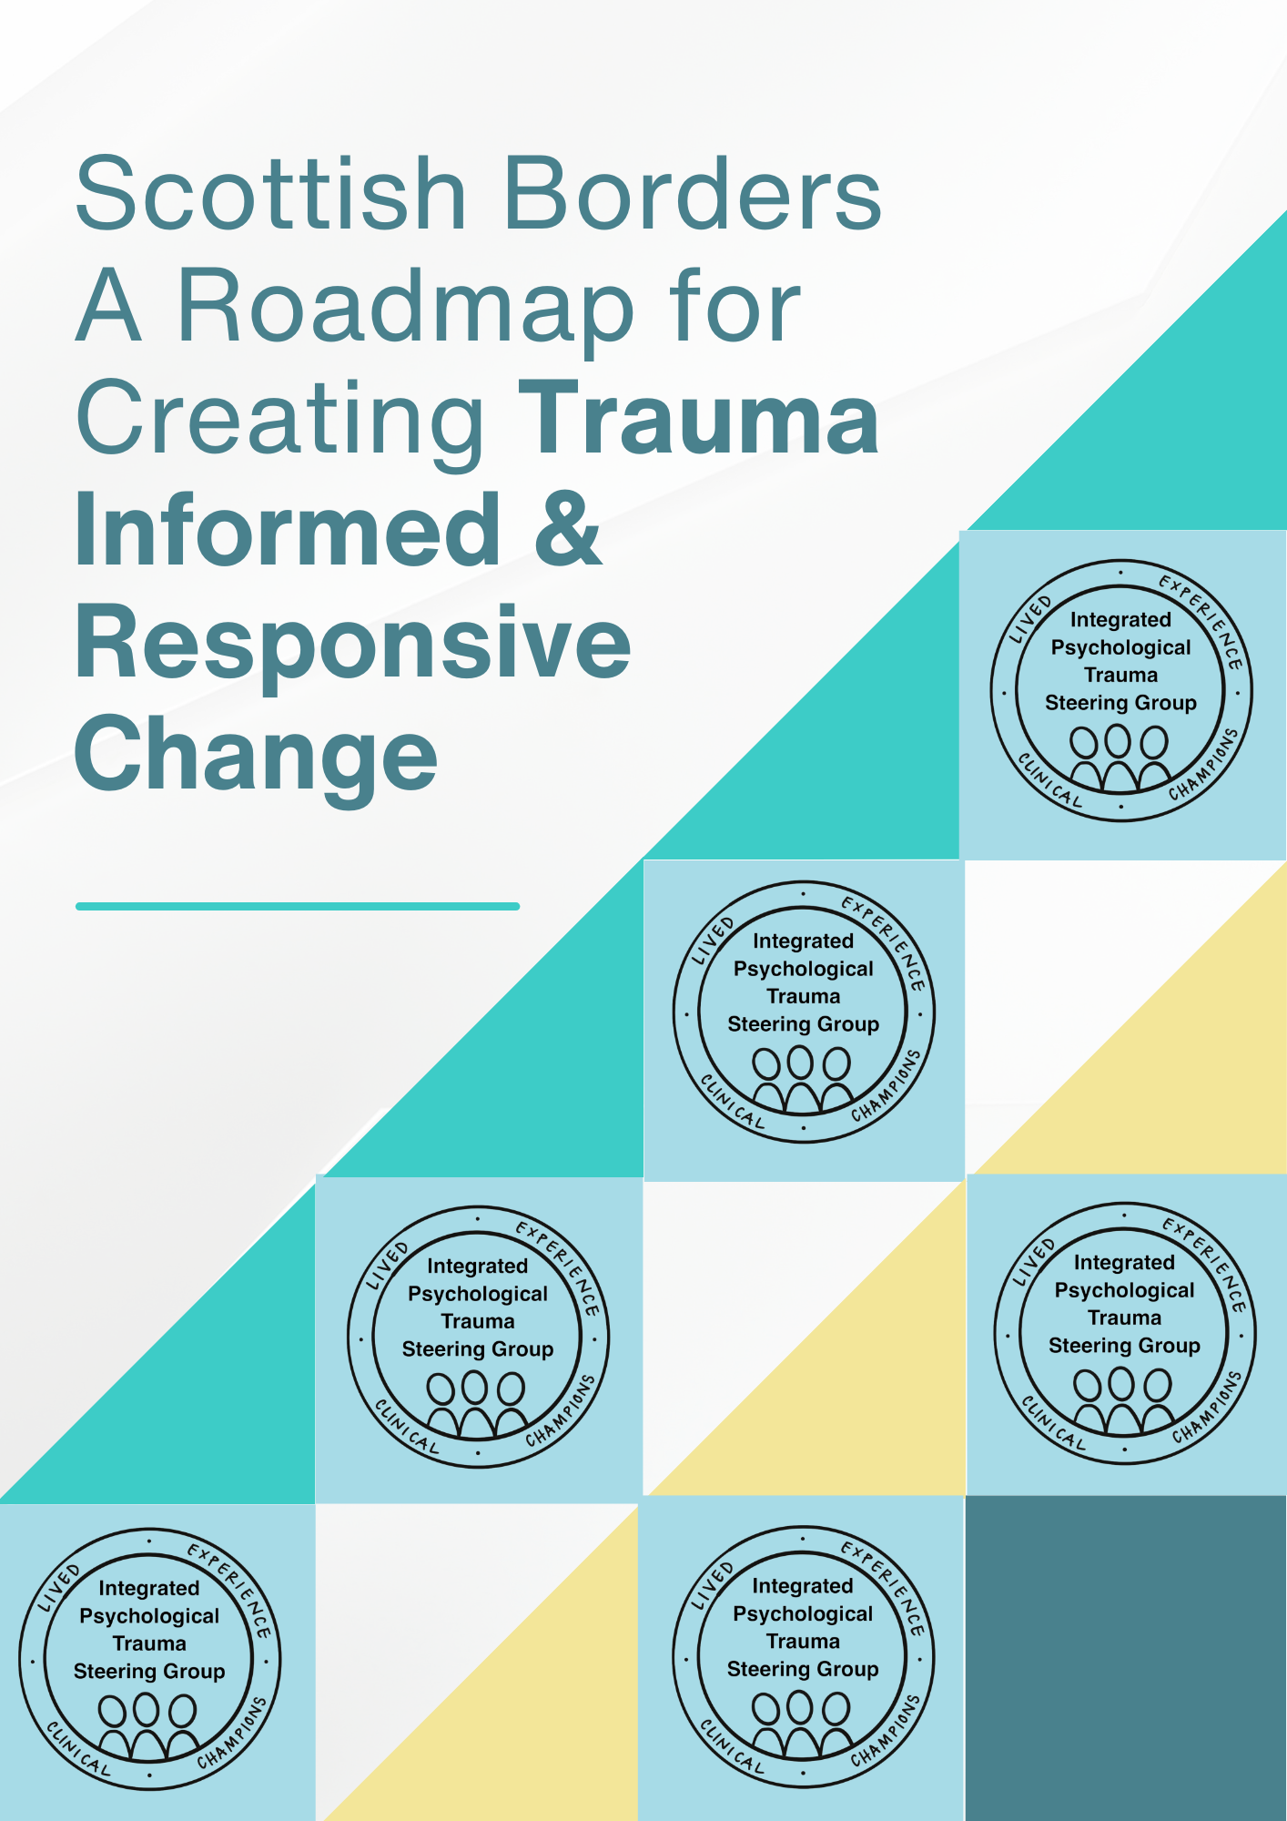
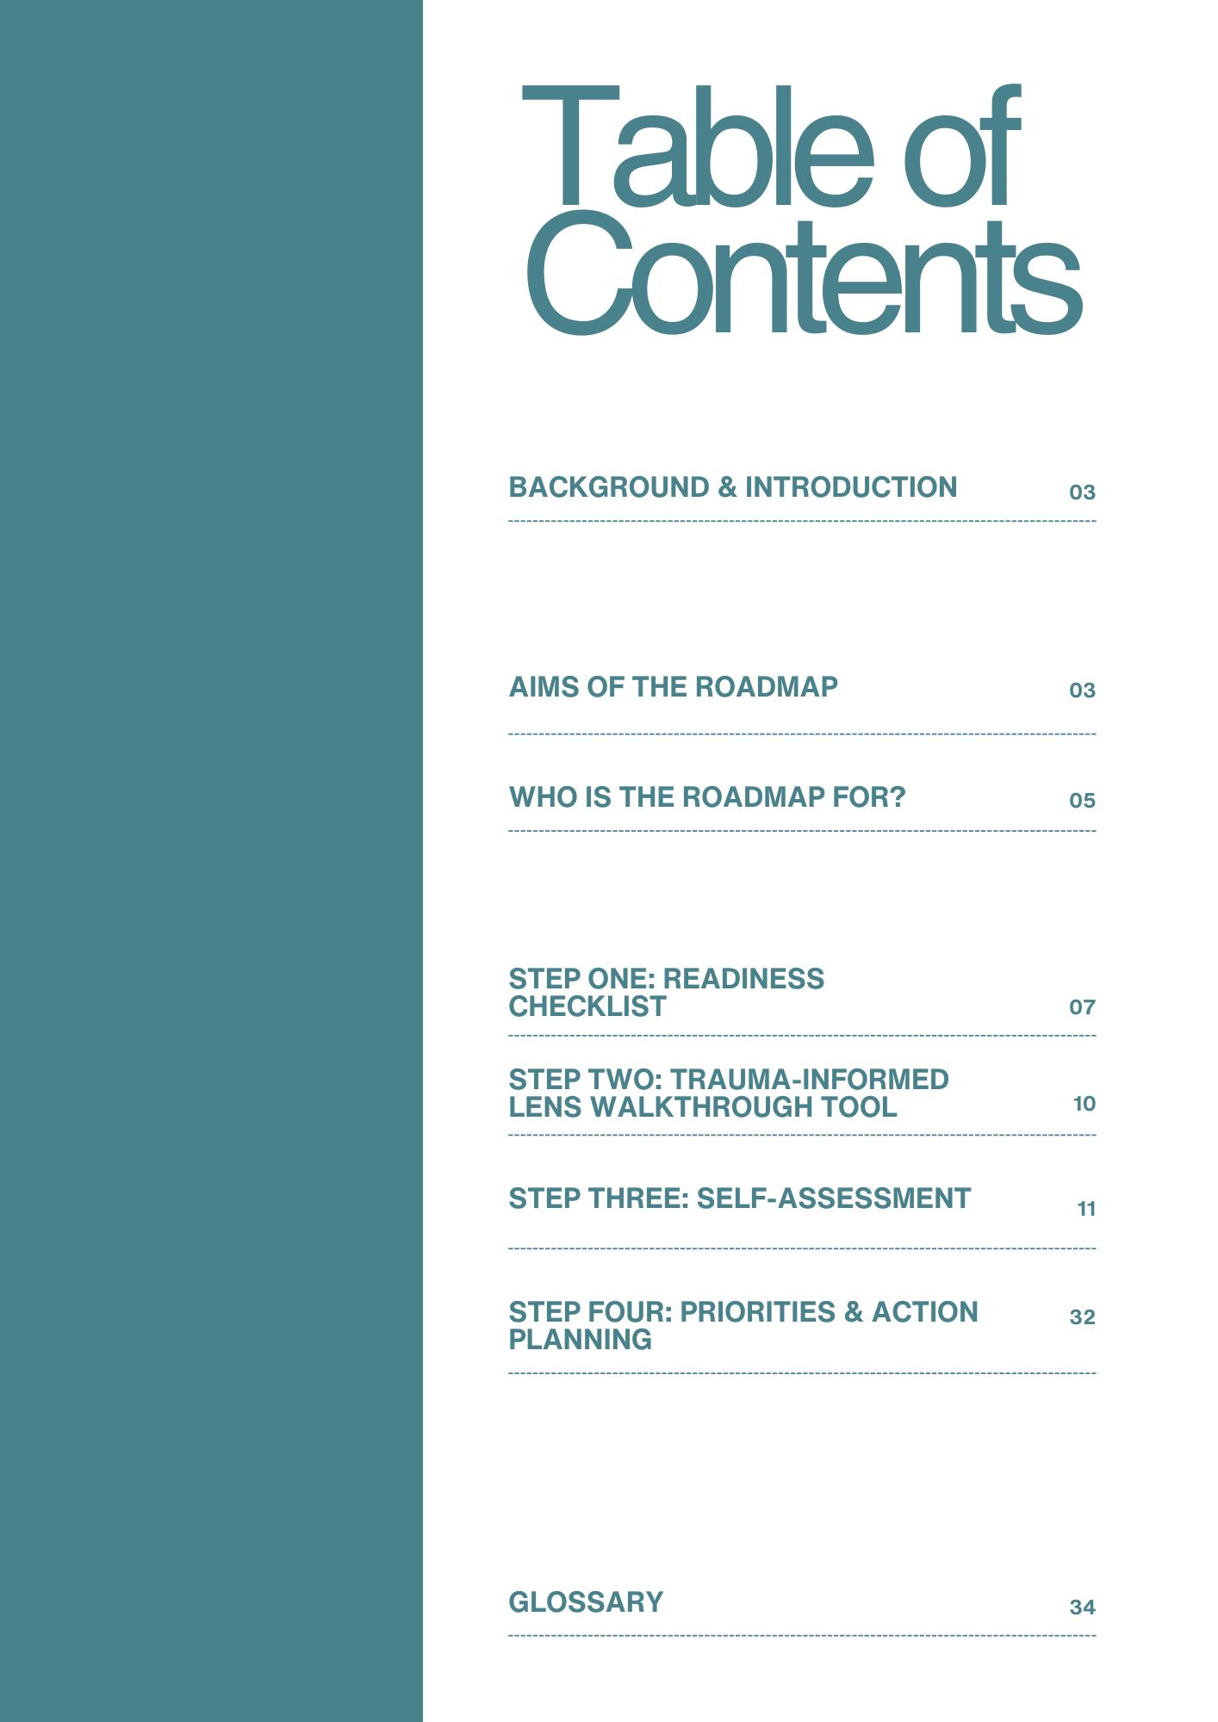

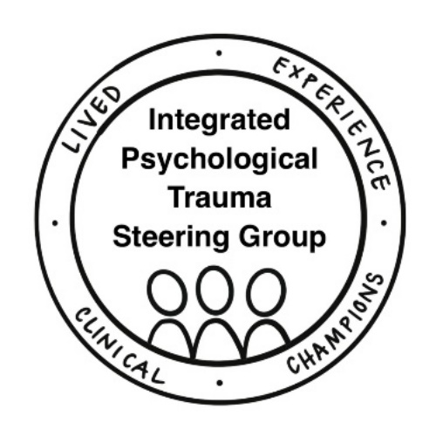
A Roadmap for Creating Trauma Informed & Responsive Change
Background & Introduction
This local Scottish Borders resource has been created using the full package of resources developed by National Trauma Transformation Programme (NTTP), which can be found at Implementation - National Trauma Transformation Programme. This version condenses the resources into one document and has been designed to help services and organisations identify and reflect on their progress, strengths, and opportunities for embedding a trauma-informed and responsive approach across policy and practice.
This resource is part of a broader range of evidence-based training and implementation tools and support developed by NTTP. More information about psychological trauma, its prevalence and impact, and the wider work of the NTTP is available on Roadmap for Creating Trauma-Informed and Responsive Change | NHS (scot.nhs.uk)

Aims of the roadmap
Raising awareness of the what, why, and how
- Demonstrate the organisational environment and conditions that are essential for embedding a sustainable trauma-informed and responsive approach.
- Highlight the different components of a trauma-informed and responsive approach and what it looks like embedded within an organisation, including the strategic and operational activities that are most effective in supporting organisations on their journey.

Supporting assessment and improvement
- Support organisations to conduct a walkthrough and self-assessment, identify and reflect on their progress, successes, strengths, and opportunities for improvement.
- Engage staff in a reflective process, viewing their own system through a trauma-informed and responsive lens. Rather than allowing an outside entity to simply observe and give judgment without intimate knowledge of the system, this participatory process encourages critical thinking, which in itself promotes organisational change and sustainability.
- Help organisations determine priorities to take forward this work, focusing particularly on ‘quality’, rather than only ‘quantity’ of work taking place to support a shift towards a trauma-informed and responsive approach.
- Recommendations from the self-assessment can be shared to facilitate wider discussion and can be the foundation for developing an action plan to help achieve better outcomes for people affected by trauma and to support workers.

Understanding progress, opportunities, and challenges
- Provide consistency across Scotland in terms of what trauma-informed and responsive organisations, systems and workforces look like and a consistent basis for tracking the progress being made around implementation.
- Gather information on the progress organisations are making on their journey to identify areas for improvement and informs future service planning and strategic investment at a local and national level, making a persuasive case for continued investment in a trauma-informed and responsive approach.
- Continue to build a national picture across Scotland to identify good practice, common opportunities and challenges, and provide useful data.

Demonstrating impact
- Support organisations to evidence the potential contributions and impact of a trauma-informed and responsive approach.
- Generate information on the social and economic impacts of trauma to help encourage local and national government, Community Planning Partnerships, and other strategic bodies to recognise a trauma-informed and responsive approach as a central part of delivering other key agendas and identify it as a priority in strategic plans.
- Contribute to the growing international evidence base on trauma-informed and responsive organisations, systems, and workforces.
- The resource should primarily be seen as a tool for organisations (and the strategic bodies to whom they report) to plan, track and reflect on their own progress in this work, supporting implementation and improvement planning.
There are likely to be considerable variations in the progress being made in different organisations, as these will respond to differing needs, geography, organisational mission, and priorities. It is expected that every organisation’s work towards embedding a trauma-informed and responsive approach will be shaped by and respond to the needs of people with lived experience of trauma in those communities and staff.

Embedding sustainable trauma-informed and responsive ways of working
Embedding sustainable trauma-informed and responsive ways of working is rooted in long-term culture change. Embedding a trauma-informed and responsive approach in an organisation usually doesn’t happen in one step. The self-assessment will support your organisation to identify key priorities and actions for improvement over time. Working towards being trauma-informed and responsive means working within a cycle of continuous improvement. We recommend that organisations use the self-assessment recurrently, in combination with feedback loops and meaningful engagement with staff and people and communities you serve, to support ongoing self-assessment, improvement planning and evaluation.

Who is the roadmap for?
The roadmap is designed for:
- People affected by trauma, their families and support networks.
- Services and organisations across the public, third, voluntary, and private sectors in Scotland.
- Workers, including paid staff, voluntary staff, and peer support workers.
- Commissioners and funders.
- Inspection bodies.
- Elected officials, local communities, and Community Planning Partnerships.

What is a trauma-informed and responsive workforce?
Trauma is everybody’s business. We all have a role to play in recognising and preventing barriers that the impact of trauma can create in relationships and services. This doesn’t mean that everyone needs to be a trauma expert. We know that different knowledge and skills are required to support people’s recovery. But it does mean that all workers, in the context of their own role and work remit, have a unique and essential part to play in recognising when someone may be affected by trauma. We need to collaboratively adjust how we work to take this into account and responding in a way that prevents barriers to opportunity, supports recovery, does no harm, and recognises and supports people’s resilience.

What are trauma-informed and responsive organisations?
Workforce training is a key component of any organisation’s journey to becoming trauma- informed and responsive. Equally important are the culture, environments, and supportive ways of working in an organisation that can enable sustainable change, which will ultimately make a difference to all who are affected by trauma. No matter how trauma-informed a practitioner may be, if workers are constrained by protocols or policies that do not recognise the impact of trauma, they may be unable to minimise the risk of re-traumatisation that training has taught us to recognise. This can risk disempowering staff and create a sense of helplessness, leading to potential disengagement from empathy for people we are supporting.
There is growing evidence that to sustainably embed a trauma-informed and responsive approach into practice, an organisation requires:
- An organisational culture that recognises the impact of trauma and sees being trauma- informed as a way of working and an approach to everything that it does, rather than as a standalone specific intervention or project, and where the key principles are intrinsic within and across the organisation and second nature to everyone.
- Leadership at all levels that understands, drives, and inspires trauma-informed change, embodies the key principles, and builds accountability for long-term improvement.
- Staff who experience their wellbeing as valued and prioritised, and have time and space to access relevant proactive, protective, and reactive wellbeing supports.
- Feedback loops from people accessing, working in and with the organisation are used to strengthen continued improvement.
- Routine, meaningful sharing of power with people with lived experience of trauma so services and systems are collaboratively designed and delivered around people’s needs, rather than around the needs of organisations and systems.
- Staff have the knowledge, skills, confidence, and capacity to recognise and respond to people affected by trauma, through training and the implementation of support relevant to their job role and service remit.
- Policies and processes that reflect an understanding of the prevalence and impact of trauma and ‘hard wire’ a trauma informed approach into all that the organisation does.
- A budget that reflects this work as a priority, supports long term commitment to embedding a trauma-informed and responsive approach and ensures there are sufficient resources for this work.
- Services are designed and delivered with a commitment to ensuring that every aspect of a person’s experience of a service, from first contact and relationships with staff to experiences of physical environments, communication, and processes such as referrals and assessments is underpinned by safety, choice, trust, collaboration, and empowerment.

What are trauma-informed and responsive systems?
All services and organisations operate within complex systems. The complexity of these systems can sometimes mean they work in ways that can be unintentionally re-traumatising, risk causing more harm, and may create barriers for those affected by trauma in accessing specialist and/or universal services and opportunities, that people need and have a right to expect. For example, people with lived experience of trauma highlight that it can be re-traumatising having to tell their story to multiple workers in different organisations and that having to navigate complex, lengthy pathways to support can leave them feeling disempowered.

Trauma-informed and responsive systems are:
Designed around an understanding of the prevalence and impact of trauma and people’s holistic needs, knowing that this may sometimes impact the smooth running of the system.
Actively supportive of services/ organisations across sectors, agencies and geographies working collaboratively, helping people to easily navigate and access the support they need, when they need it and for however long they need it. This helps people to see services and systems as trusted and supportive resources.
Facilitated by a joined-up approach to funding, national priorities and reporting requirements, designed to help services/ organisations respond to their communities’ own unique needs and priorities.
Awareness that this work can’t be done individually. It requires collaboration and power sharing across communities, public, third and private sectors, and local and national government. Responding in a trauma-informed way is necessary but not sufficient in developing organisations and systems that are fair, equitable and help people access the right support at the right time.
We must learn to avoid locating responsibility and blame for the experience and impact of trauma on an individual. For example, it is crucial that systems, services, and staff understand and respond to the cultural and gendered context of specific kinds of trauma such as gender-based violence, hate crimes and child sexual exploitation. Equally Safe, Scotland’s strategy for preventing and eradicating violence against women, recognises that women and girls are at an increased risk of violence and abuse precisely because they are female in our unequal society. If we are to improve outcomes for women, children and young people affected by gender-based violence and hold perpetrators to account, it is critical that staff are trained in the ways that discrimination and oppression both impose constrained choices on women and girls and enable violence perpetrated by men against them.

Step one: Readiness checklist
Research tells us that to successfully implement a trauma-informed and responsive approach an organisation needs to have a competent and confident workforce, organisational support and effective leadership. Without having these in place, trauma training or any other intervention aimed at trauma-informed and responsive change is unlikely to result in sustainable improvements.
The brief checklist below can help you to consider whether your organisation is ready, willing and able to do this work safely and effectively and may help to identify areas that need further consideration.
The questions / reflection points below are for ANY organisation looking to embed a trauma-informed and responsive approach.
Organisational culture and leadership: | Yes / No / Comment
Is there agreement amongst strategic and operational leaders in your organisation that embedding a trauma-informed and responsive approach is important and is in alignment with existing priorities?

Is there agreement and momentum that this is the right time for the organisation to begin this work?

Do leaders have capacity to engage with this work?

Is your organisation ready and able to ensure staff have the capacity to complete the self-assessment and identify what strategic and operational changes might be necessary to sustainably implement a trauma-informed and responsive approach within their work?

Additional Comments:

Staff care, support and wellbeing:

What supports are already in place for staff wellbeing?

What do you know about current workforce pressures in your organisation (e.g., workloads, absences, retention, recruitment, skill mix)?

Comments:

Staff knowledge, skills and confidence: | Yes / No / Comment
What opportunities/ structures exist for staff to consolidate new knowledge and successfully implement new skills within their workplace?

Have any staff in your organisation already attended trauma training?

Are any staff already championing a trauma-informed and responsive approach?

What awareness is there of trauma-informed and responsive practice and the National Trauma Transformation Programme?

Are there existing groups or forums you could use to promote a trauma informed and responsive approach?

Additional Comments:

If your service/ organisation has a specific remit to support people affected by trauma, you may find it helpful to consider these additional questions
Staff care, support and wellbeing: | Yes / No / Comment
What 1-1/ group supervision arrangements and reflective practice arrangements do you already have in place?

Are workers engaged with these?

How does your organisation usually respond if a worker is experiencing issues relating to past trauma which is impacting on their work?

Are managers and supervisors familiar with the concepts of vicarious and secondary trauma?

Are managers and supervisors confident talking with workers about the impact of working with people who have experienced trauma?

Additional Comments:

Staff knowledge, skills and confidence: | Yes / No / Comment
Do you have workers within your organisation who are trained to the appropriate level to provide post training support?

Do supervisors and line managers feel confident and able to talk about trauma-informed practice within their line management sessions?

Additional Comments:

What is in place now to support change? What gaps have you identified?
Comments:

Step two: Trauma-informed lens walkthrough tool
Use this section to note the extent to which each relevant area of the service is trauma informed. Tick the box to select your organisation’s current progress level. Use the evidence section to provide reasoning behind this choice.
Red = Not trauma informed
Amber = Some elements trauma informed, but many are not

Green = Trauma informed
Red flag = Risk of active re-traumatising or introduction of primary trauma.

Organisational Area | Red Flag | Red | Amber | Green | Evidence
Access

Physical Environment

Relationships

Supporting Recovery

Partnership Working

Communications and Language, Materials and Media

Step three: Self-assessment
Once you’ve completed the readiness checklist and walkthrough tool to support reflective, collaborative discussions about whether your organisation is ready to start this work, your next step is the self-assessment. The self-assessment provides a suggested roadmap of activities to support sustainable and effective progress towards becoming trauma informed and responsive, recognising that this is a journey, and this work won’t all happen at once.
The self-assessment tool is designed to be flexible. You can use it to suit your needs. Depending on your team/service/organisation, some of the questions might not be relevant, so please adapt/omit as needed
The roadmap is broken into six stages, starting with initial activity, right through all the stages of the implementation journey. The six stages include:
- Creating the right conditions
- Understanding experiences of our organisation systems and how we currently work
- Developing our aims
- Implementing and testing change across our organisation and practice
- Consolidating change across the organisation, systems and practice
- Ensuring sustainability
For each section that is relevant, please first decide at what point of the journey your organisation is at and focus on the relevant questions related to that section before moving onto the next stage within the area. Some sections only come under a few stages whereas others come under each of the different stages.
The areas that are considered include: Leadership; Staff care, support and wellbeing; Feedback loops & Continuous improvement; Power sharing with people with lived experience of trauma; Staff knowledge, skills and confidence; Policies and processes; Budgets; How we design and deliver services.
Please rate the extent to which you agree/disagree as to where your organisation is currently at using the following scale:
1= Strongly Disagree
2= Disagree
3= Neither Agree nor Disagree
4= Agree
5= Strongly Agree
You’ll be asked to provide evidence and reflections that support your views. This is designed to support you to collectively develop an action plan for your organisation.
The self-assessment includes a mix of strategic and operational questions. It can be helpful to consider which staff will need to be involved so that you have a robust and meaningful insight across all the questions.
It is also helpful to consider what are the opportunities for people with lived experience of trauma to be safely and meaningfully involved in the self-assessment, for example, if you already have established forums/panels/feedback loops in place.
When completing the self-assessment, remember this is a journey. You will likely identify progress for some of the suggested activities and less for others.

Leadership | Rating (1 to 5) | Evidence / Things that need to be put in place
Creating the right conditions
Leaders have completed the organisational readiness checklist to reflect on whether our organisation is ready to begin this work.
We have listened to our staff to understand the capacity of our organisation, and staff capacity to create and sustain change at this time.
Leaders have accessed high-quality, relevant training and follow-up support, including training on trauma-informed leadership and organisations and the impact of trauma on staff wellbeing. This also includes follow-up reflective sessions from the STILT workshops.
Leaders have established appropriate scaffolding to support this work in our organisation, including a steering/ implementation group with a Terms of Reference and appropriate governance routes to support long-term accountability.
All steering/implementation group members have accessed high-quality, relevant training for developing their knowledge of trauma-informed leadership and organisations.
Leaders have collaboratively developed a long-term shared vision and commitment to embedding a trauma-informed and responsive approach and are clear about what ‘good’ looks like.
Leaders have communicated the long-term shared vision across the organisation.
Developing our aims
We have developed an organisation-wide action plan to support our long-term shared vision for and commitment to this work.
We have drawn on learning from this self-assessment to help us understand current progress with this work across our organisation, our strengths and areas for improvement.
We have drawn on learning from feedback loops with people accessing, working in and with our organisation, of the extent to which we are achieving the outcomes, and we have identified our aims and vision for this work.
We have drawn from collaborative discussions among staff, people with lived experience of trauma and leaders (recognising that we often fall into more than one of these categories) involved in our steering/ implementation group.
We have put processes in place to ensure continuous review, accountability for and implementation of this action plan, clearly identifying how this work supports existing relevant organisational/ local/ national priorities.
Implementing and testing change across our organisation and practice
Our organisation has: Ensured leaders have access to coaching, peer support and/ or collaborative learning support networks with other leaders, and opportunities for reflective learning and reflective practice supervisions, as required.

Consolidating change across the organisation, systems and practice
Our organisation has leaders who pro-actively support each other to model and develop a trauma-informed and responsive organisational culture as part of their leadership practice (e.g., reinforcing trauma- informed and responsive ways of working, creating an environment that supports people to try different ways of working, celebrating successes, embodying the five key principles).
Our organisation has leaders who empower people across the organisation, including people with lived experience of trauma, to collaborate and lead on this work in their own spheres of influence.
Ensuring sustainability
Our organisation has developed the long-term internal infrastructure and support for this work beyond specific individuals in the organisation (e.g., train the trainers models for training and implementation support, peer learning opportunities, standing agenda item across services).
We have embedded relevant trauma training in our organisation’s leadership development programmes as routine.
Our organisation has people with lived experience of trauma in leadership and governance roles in our organisation, and this expertise through experience is embraced and supported.
We have included in our key strategies/ plans a long-term commitment to sustainably embedding a trauma-informed and responsive approach and articulate why this is important.
We have leaders who can evidence that the outcomes determined by our organisation in our vision and action plan are being worked towards/delivered, and leaders routinely articulate why being trauma-informed and responsive is important for our organisation.
We have leaders who champion and encourage partner agencies/ organisations to work in a trauma-informed and responsive way and help to create a shared understanding and language around trauma across the systems in which we work.

Staff care, support and wellbeing | Rating (1 to 5) | Evidence / Things that need to be put in place
Creating the right conditions
Our organisation has recognised and communicated that there is no ‘them and us’.
Our organisation has recognised that we may work in roles where we are exposed to traumatic experiences, which means we may face an increased risk of experiencing vicarious trauma, burnout, chronic stress, moral injury, and compassion fatigue.
Our organisation has reviewed information gathered from existing feedback loops from staff about their wellbeing and working conditions, and/ or engaged with staff to review current working conditions and to what extent we have a healthy workplace culture.
Working conditions include: people’s basic needs for hydration and access to food, a safe physical work environment that isn’t overcrowded, has good lighting and temperature and access to bathroom facilities, clear and manageable working patterns/hours, flexible working where possible and reasonable adjustments, access to IT and communications systems, safe number of working hours, sufficient staffing levels, and ensuring staff are paid on time and correctly.
Exploring ways to ensure staff can express safety concerns without worrying that they will be seen as unwilling and unable to do their job. This includes clear governance and processes for staff to raise concerns.
Discussing wellbeing at staff meetings, having protected time for wellbeing, and facilitating wellbeing sessions.
Capacity for people to take regularly scheduled breaks, ensure people can take annual leave, time for personal development reviews and 1-1s.
Creating opportunities to collectively recognise and celebrate successes, achievements, and good practice.
Developing our aims
Our organisation has developed staff wellbeing plans at individual and organisational levels, in alignment with any relevant local and national guidance/policy.
Our organisation has identified what proactive prevention measures to support staff wellbeing are already in place and what gaps there might be.
Our organisation has identified what policies and processes are in place for how to respond to critical events.
Implementing and testing change across our organisation and practice
Our organisation has developed staff and organisational wellbeing plans, in alignment with any relevant local and national guidance/policy.
Our organisation has ensured that any gaps identified in our wellbeing needs analysis around our organisation’s proactive and reactive supports are being addressed and the role of those supports in strengthening staff wellbeing are widely communicated across our organisation.
There are mechanisms to regularly review feedback loops from staff to ensure they feel their general working conditions support their wellbeing, they have the space and time to access what they need to stay well and feel able to effectively engage with training and new practices that will support our vision and outcomes for this work.
Ensuring Sustainability
Our organisation has collaboratively developed a staff care, support and wellbeing policy that specifically considers the impact of trauma and vicarious trauma experienced within/out with work on staff.
We have ensured that whenever our organisation is looking to make changes (e.g. implementing a new policy or changing a rota system), we use staff feedback loops to consider how well our staff currently feel, taking a collaborative and transparent approach to designing and implementing changes, and we make sure there is relevant support during and after any changes are implemented.

Feedback loops & Continuous improvement | Rating (1 to 5) | Evidence / Things that need to be put in place
Understanding experiences of our organisation, systems & how we currently work
Our organisation has identified the existing ways we gather feedback from people accessing, working in and with our organisation to ensure that feedback informs the development of our action plan.
These feedback loops have helped us to build a picture of people’s experiences of accessing, working in and with our organisation, what is working well and what could be improved.
These feedback loops have helped assess to what extent we are achieving the outcomes we have identified in our aims and vision for this work and identify our strengths and opportunities for further embedding a trauma-informed and responsive approach across policy and practice.
Developing our aims
Our organisation has developed our action plan based on our vision and aims for this work. We are clear what ‘good’ looks like and the tangible outcomes we seek to achieve through embedding a trauma-informed and responsive approach, for our organisation and the people and communities we serve.
We understand that success will be reflected in measuring these outcomes, rather than only tracking the progress of activities or outputs.
We used our initial earlier scoping to identify any gaps in and opportunities to strengthen our feedback processes to prioritise within the action plan.
We have considered multiple ways for people to provide feedback (e.g., written, online, hard copies) and have clear processes for welcoming, collating, and responding to unsolicited feedback, for example in conversations with a staff member or peers.
We have considered opportunities that ensure anonymity and confidentiality if required.
We have flexibility around what kind of feedback is sought, e.g., open ended questions.
We have considered when people are asked for feedback and how often.
We have developed relationships; feedback will be offered routinely and informally if these relationships are meaningfully developed.
We have given consideration around the types of questions being asked (e.g., could they cause distress or harm?).
Consolidating change across the organisation, systems and practice
Our organisation has robust information systems that give us a clear picture of the extent to which we are achieving or working towards the outcomes set out in our vision/aims and action plan. This includes drawing on feedback loops with people who access, work in and with our organisation, existing quantitative and qualitative data that we already collect about our services, case studies, case file audits, etc.
We have created an organisational culture that creates robust and meaningful feedback loops with staff so that we can understand the impact on them of any changes to practice and ways of working. These feedback loops are easy, accessible, and confidential and help us gather routine feedback from staff about working conditions, their experiences of our organisation and its culture, and the impact of their work on their wellbeing.
We have collaboratively reviewed our complaints process to ensure it is user-friendly, intuitive and easily accessible. This might involve reflecting on the power dynamics within the process and how to minimise these, using non-judgemental questions and responses, acknowledging that people’s memories of experiences/ events might be non-linear, being transparent about how people’s information will be shared and when, and ensuring that the process is timely and clearly communicated.
Ensuring Sustainability
Our organisation has created a culture where there is ‘no wrong door’ for people to provide feedback. People accessing, working in and with our organisation feel that their feedback is welcomed and proactively sought.
Our organisation has processes for routinely collecting and analysing feedback from people accessing, working in and with our organisation. Learning from analysis of feedback influences changes and improvement in our organisation.
Changes as a result of feedback are clearly communicated to staff and/ or people in contact with our organisation, where relevant (e.g., ‘you said, we did’). Where changes can’t be made, this is communicated explaining why.
We have processes for routinely collecting and reviewing staff feedback on working conditions, experiences of the organisation, its culture and their impact on worker wellbeing, and whether workers have the time and capacity to access proactive and reactive supports if required, and what the challenges might be in doing so.
Our organisation makes it clear to staff that it values and trusts this feedback and makes it safe to identify challenges.
Our organisation has focused on continuous improvement, using feedback, learning from our power sharing work and regular review of services through a trauma-informed lens. This helps us measure our progress in embedding a trauma-informed approach and builds a picture of the impact this work, and helps us understand to what extent we are achieving the outcomes identified in our vision and action plan.
Our organisation has developed opportunities to partner with other trauma-informed and responsive organisations for mutual peer review, ‘critical friend’ input, learning and insight.

Power sharing with people with lived experience of trauma | Rating (1 to 5) | Evidence / Things that need to be put in place
Understanding experiences of our organisation, systems & how we currently work
Our organisation has ensured leaders and all members of our steering/implementation group have accessed high-quality, relevant training for developing knowledge of trauma-informed leadership and organisations to strengthen their understanding of what power sharing is and why it is vital for developing a trauma-informed and responsive organisation.
We have scoped current examples of good practice in power sharing in our organisation. We have identified any existing groups/forums that represent people with lived experience of trauma in our community with whom to initially collaborate in creating safe and meaningful membership of people with lived experience of trauma in the steering/implementation group.
Developing our aims
Our organisation has worked collaboratively with existing groups/ forums that represent people and communities with lived experience of trauma to develop processes to ensure people with lived experience of trauma have been involved in the development of our organisation’s action plan.
We have identified key priority areas in our organisation for collaboratively creating safe and meaningful processes for power sharing. Recognising that safe and meaningful power sharing takes time, this could be in specific priority services, projects or work identified through feedback loops from staff and people affected by trauma, where it is felt power sharing among people with lived experience of trauma, staff and leaders could have the most positive impact.
Implementing and testing change across our organisation and practice
Our organisation has ensured that, for the teams/services identified in the action plan as priority areas for developing power sharing mechanisms, all relevant staff have accessed high-quality, relevant training for developing knowledge and understanding of power sharing with people with lived experience of trauma, that is co-delivered with people with lived experience of trauma.
Consolidating change across the organisation, systems and practice
Our organisation has collaboratively developed ways for people with lived experience of trauma to be safely and meaningfully involved in our organisation, reflecting the priority areas we identified in our organisation-wide action plan.
We have considered accessibility and safe physical environments and settings for meetings/ events, whether online or in person.
We have identified what practical support is needed for people to be involved (e.g., transport, childcare, refreshments, internet and phone access).
We have considered methods of participation (e.g., people attending steering/ implementation group meetings, a representative attending, a separate supported group that feeds into the steering/ implementation group).
Remuneration for people’s time and expertise, taking into account the impact of payments on people’s individual circumstances.
We have identified any training, support, coaching, and learning and development opportunities that might be needed by people with lived experience of trauma who are involved in this work, such as opportunities to develop transferable skills, if people wish to.
We have provided training and support to staff to ensure they feel confident in collaborating with people with lived experience of trauma, and there are ongoing opportunities to discuss concerns and barriers to implementation.
We have collaboratively agreed methods of communication, timescales, scope and remit around the work, providing as much detail as possible in advance, agreeing everyone’s expectations for the group and members.
We have considered how people can withdraw if they no longer wish to be involved and what flexibility is there to find alternative ways of participating for people who are facing barriers to engage.
We have identified opportunities for staff with lived experience of trauma to be involved in this group or through other mechanisms, if this is something staff identify through regular feedback loops as being useful.
We have considered creating safe environments and building relationships, such as collaboratively identifying ways to build trusting relationships among everyone involved, recognising that this takes time and collaboratively developing a joint understanding of what power sharing can look and feel like within the group.
We are collaboratively working with people with lived experience of trauma and experts by profession to consider the impact of trauma on people’s experiences of relationships and power dynamics, and that this work may impact on people’s wellbeing, mental health and potentially cause re/ traumatisation for anyone involved. We have considered what support is needed around this and how people’s different perspectives and experiences can be safely heard.
As a group, we are working together to address the realities of power dynamics. How are agendas shaped to ensure everyone has a voice? How can quieter/ diverse voices be included and heard? What language might be disempowering and how can we create a shared language, avoiding jargon? How can we create opportunities to draw on different strengths, skills and perspectives?
Ensuring Sustainability
Our organisation has embedded safe, meaningful, and routine processes for power sharing across all areas of our organisation. This includes evidencing how the voices of lived experience of trauma are at the heart and start of how we design and deliver our services.
We can evidence how people with lived experience of trauma are collaboratively involved in setting our organisational outcomes and performance measures/indicators.
We can evidence how people with lived experience of trauma are in leadership/ governance positions in our organisation.
We can evidence how people with lived experience of trauma are involved in our recruitment processes.
We have included the costs of collaboration on service design, delivery and priority setting with people with lived experience of trauma in our organisation’s budgets and funding proposals.
We have developed a policy around collaborating with people with lived experience of trauma and/ or this is woven through existing policies. We collaboratively and routinely review guidance, processes and policies around power sharing, and proactively identify further opportunities.
We have ensured that we pro-actively encourage people with lived experience of trauma to apply for roles in our organisation and we value this expertise. We have adapted our job descriptions to support this commitment
We have identified how to meaningfully collaborate with quieter and diverse voices of lived experience of trauma (e.g., people who may wish to access services but are facing barriers in doing so, people with protected characteristics).

Staff Knowledge, skills and confidence | Rating (1 to 5) | Evidence / Things that need to be put in place
Understanding experiences of our organisation, systems & how we currently work
Our organisation has completed a workforce training needs analysis in relation to the Transforming Psychological Trauma: A Knowledge & Skills Framework for the Scottish Workforce to identify who needs to know and do what proportionate to their role in relation to trauma. This includes all members of staff (paid, volunteer, peer support) in our organisation.
The training needs analysis also considers what training staff may need around wellbeing.
It considers what implementation supports and structures exist and/ or will be needed to translate training into practice (e.g., peer support, reflective practice, coaching or supervision).
It considers what training managers/ leaders may require around reflective practice/ supervision.
It considers what training staff may require around developing safe and meaningful power sharing with people with lived experience of trauma.
Our organisation has released all staff, including support and administrative staff, to access initial training so they have a baseline knowledge of trauma (e.g., the Informed level). All staff have received information about why they are being asked to complete the training and have had opportunities to discuss existing good practice, any concerns/ challenges and how a trauma-informed approach can support their existing work with peers and managers.
Developing our aims
Our organisation has used our training needs analysis and the Scottish Psychological Trauma Training Plan to develop a workforce trauma training plan.
We have identified staff to prioritise for trauma training (e.g., particular groups of staff, teams, services).
We have identified high-quality trauma training and effective trauma trainers who demonstrate evidence that they possess a high level of knowledge and skills relevant to the area of trauma they are providing training in, including demonstrable experience of having applied trauma-related knowledge and skills in a relevant real world setting (for trainers training staff at trauma skilled, enhanced and specialist levels).
We have identified how people with lived experience of trauma will be involved in the delivery of training.
We have identified what is needed so that staff have the time, space, capacity and implementation support to attend training, consolidate new skills and translate trauma-informed learning into practice.
We have developed an evaluation plan to understand whether the training is well-received by staff, has met the intended learning outcomes, brings about change in what staff do in practice, the impact of these changes for people accessing, working in and with our organisation, and the impact of the changes on the outcomes we identified in our vision and action plan.
Implementing and testing change across our organisation and practice
Our organisation has released all workers to access the appropriate trauma training relevant to their role (if they require anything beyond initial training they have received). Staff have received information about why they are being asked to attend the training and how a trauma-informed approach can support their existing work, and there is a clarity of expectations around what this means for them before, during, and following training.
Our organisation has ensured all workers receive ongoing implementation support relevant to their role to develop confidence and support them to apply their knowledge and skills into practice in line with pp.33-36 of the Scottish Psychological Trauma Training Plan.
Depending on staff role, this may include structured implementation support, discussions at team meetings, 1-1s, de-briefs, peer support, coaching, clinical supervision and reflective practice, provided by suitably trained supervisors.
We have ensured that staff have opportunities to identify and discuss any tensions between working in a trauma-informed way and the core functions of our organisation, as well as discuss any concerns and challenges around trauma-informed practice.
Consolidating change across the organisation, systems and practice
Our organisation has ensured workers have access to additional training to support working in a trauma-informed and responsive way with the people we support, where relevant (e.g., managing grief, bereavement, violence against women).
Our organisation has ensured there are regular opportunities for staff to reflect on their work, in addition to relevant ongoing formal training and implementation support.
This may include considerations around strengthening a supportive and inclusive organisational culture of reflection and critical thinking that encourages workers to process their personal history, biases and fears with supervisors, peers and coaches in a non-judgmental way; encourages open and honest reflection about work, the strengths people bring to their jobs and what keeps the work meaningful.
Actively monitoring and responding to feedback from staff about the training and any challenges they may face in practical implementation of knowledge and skills and making any relevant changes.
Using feedback and evaluation to identify, celebrate and communicate examples of good practice and positive changes to practice following training.
Ensuring Sustainability
Our organisation has: Identified and embedded trauma training and relevant implementation support as a routine part of our induction processes and ongoing workforce development.
We have ensured our recruitment processes include expectations around trauma-informed and responsive knowledge and skills.
We have ensured our workers are released to access continued training opportunities to support good practice.
We have communicated that supervision/reflective practice is a priority. Leaders see this support as essential and ensure time is protected for workers.
We have ensured workers have opportunities to link in with local and/ or national forums and communities of practice to share learning.

Policies and processes | Rating (1 to 5) | Evidence / Things that need to be put in place
Developing our aims
Our organisation has identified existing examples of good practice in our organisation in terms of trauma-informed and responsive policy, processes and/ or guidance and, as part of our action plan, identified priority policies, processes and/ or guidance for review through a trauma-informed lens.
To identify good practice and priorities for review, we have considered any positive/negative feedback about existing policies, processes and/or guidance, any concerns that have been highlighted by people accessing, working in or with our organisation about specific policies, and identified any gaps in current policies that are needed to support this work.
We have considered where adaptations to policies, processes and/ or guidance are most likely to positively support the outcomes identified in our vision and where changes could most likely positively impact people accessing, working in or with our organisation (for staff, this could be policies around bullying and harassment, lone working, for example).
Consolidating change across the organisation, systems and practice
Our organisation has: Reviewed the policies, processes and/or guidance that we identified in our action plan as a priority for review through a trauma-informed lens.
We identified key stakeholders, including people with lived experience of trauma and staff most likely to be affected by the policy, as well as relevant decision makers, who would need to be involved in the review (understanding that there will likely need to be different stakeholders involved for different policies).
We identified who needs to sign off revised/ new policies in our organisation and ensured accountability for who will oversee implementation of recommended changes and ongoing review over time.
Leaders have supported the changes identified through the review. Where relevant, we have communicated to people accessing, working in and with our organisation what those changes are and why they have happened, and we are using feedback loops and data to understand the impact of those changes.
Ensuring Sustainability
Our organisation has an ongoing programme of review to ensure all of our organisation’s new and existing policies, processes and guidance have been reviewed through a trauma-informed lens.
We have clear processes in place around changes to policies and processes following review, including ensuring communication of: a) changes to policy if they affect people with lived experience of trauma coming into contact with our organisation and b) practical implications of changes for staff and identify where training and other additional support might be required as a result of the changes.

Budgets | Rating (1 to 5) | Evidence / Things that need to be put in place
Developing our aims
Our organisation has identified costs associated with remuneration for people with lived experience of trauma to be meaningfully involved in initial activity for this work (e.g., membership of the steering/ implementation group, contributing to the development of our action plan) and have collaboratively identified how people can be remunerated (e.g., taking into account the impact of payment on people’s specific circumstances).
We have determined the in/direct costs, time, and resources required to implement and sustain our action plan. Our organisation has allocated resources to support priority areas of this work that will have the most impact for people accessing, working in and with our organisation.
Ensuring Sustainability
Our organisation has identified opportunities across different policy agendas/services/ partners to pool budgets to support embedding a trauma-informed and responsive approach across our organisation or local area.
We have used data, evidence and feedback loops to build a picture of the possible costs of the impact of trauma for our organisation and the impact that this is having on our organisation’s priorities.
We have developed clear guidance around remuneration for people with lived experience of trauma who share time and expertise with us, and resources for this work are allocated accordingly.
We have identified any financial processes that could be reviewed through a trauma-informed lens. For example, if we commission services, our commissioning and procurement frameworks ask providers to indicate how they deliver trauma-informed and responsive services.
If we are a funder, the key principles are embedded in our application and reporting processes. For example, we consider timeframes (e.g., the quick turnaround of applications, the need for funds to be spent by the end of the financial year, how long the funds last); how these timeframes can impact workers and teams (e.g., how long the work/project can last, time spent in writing applications, how timescales can affect the team’s capacity, future forecasting and sustainability); and reporting requirements (e.g., what data are we asking organisations to collect and report on and why; how can people accessing, working in and with an organisation we are funding define what ‘success’ looks like?).
We have ensured that our budget setting process is, where possible, informed by people accessing and working in our organisation, through feedback loops and our mechanisms for power sharing.

How we design and deliver services | Rating (1 to 5) | Evidence / Things that need to be put in place
Developing our aims
Our organisation has identified a small number of priority services/teams to complete a trauma-informed lens walkthrough. To help us identify priority services/teams, we have used feedback loops, our engagement with people with lived experience of trauma, and any other data and information to reflect on where a walkthrough could have the most positive impact for people accessing, working in and with a service, and where this will help us achieve our aims and outcomes for this work.
Please note: This may look different depending on the size and remit of your organisation. If you’re a small organisation, you may be able to complete the walkthrough collectively as an entire organisation. If you’re a large and complex organisation, it may be helpful to identify a small number of services/ teams as ‘tests of change’ for this piece of work. Teams across departments/ services could come together for a trauma-informed lens walkthrough workshop to support shared learning but work within their own teams to review and develop their own specific plans.
Implementing and testing change across our organisation and practice
Our organisation has supported the teams/services we identified as a priority for completing the trauma-informed lens walkthrough to complete this activity. This will provide a baseline audit of strengths and opportunities for strengthening how we deliver a trauma-informed and responsive service. The walkthrough has helped priority teams/ services to develop their own individual action plans around service design and delivery.
Consolidating change across the organisation, systems and practice
Our organisation has: Supported the priority teams/services who completed the trauma-informed lens walkthrough to start to implement the changes they identified during the walkthrough.
We have identified who needs to authorise changes and ensure accountability for who will oversee implementation of recommended changes and ongoing review over time.
Leaders have supported the changes identified through the review. Where relevant, we have communicated to people accessing, working in and with our organisation what those changes are and why they have happened, and we are using feedback loops and data to understand the impact of those changes. We are actively identifying and celebrating where changes have supported the outcomes that we identified in our vision and action plan.
We have mechanisms for sharing learning across our organisation from these ‘tests of change’.
Ensuring Sustainability
Our organisation has supported every team/service to complete an initial trauma-informed lens walkthrough to provide a baseline audit and help develop an action plan identifying strengths and opportunities for improvement in terms of embedding a trauma-informed and responsive approach.
We have supported every team/service in our organisation to develop mechanisms for regular review (e.g., using feedback loops from staff and people with lived experience of trauma to continually identify opportunities for improvement), using the lens walkthrough tool in team meetings to discuss good practice and opportunities for improvement.
We have developed meaningful opportunities to bring together key stakeholders including staff, people with lived experience of trauma and decision makers to complete a trauma-informed lens walkthrough of new services to ensure we are embedding the key principles of a trauma-informed and responsive approach at every stage of the design process.

Please provide evidence that supports your views on your organisation’s progress in creating the right conditions for this work and identify any areas for improvement.

Please provide evidence that supports your views on your organisation’s progress in understanding experiences of our organisation, systems and how we currently work and identify any areas for improvement.

Please provide evidence that supports your views on your organisation’s progress in developing aims and identify any areas for improvement.

Please provide evidence that supports your views on your organisation’s progress in implementing and testing change across the organisation and practice and identify any areas for improvement.

Please provide evidence that supports your views on your organisation’s progress in consolidating change across the organisation, systems and practice and identify any areas for improvement.

Please provide evidence that supports your views on your organisation’s progress in ensuring sustainability and identify any areas for improvement.

Step four: Priorities and Action Planning
Once your organisation has completed the self-assessment to identify your progress, strengths and opportunities for improvement in embedding a trauma-informed and responsive approach, the next step is to use those findings to identify key priorities for your organisation and work through the template below to develop an action plan. The template can be amended as needed.
What are our intended outcomes for embedding a trauma-informed and responsive approach in our organisation?

What priorities have we identified through completing the self-assessment?
Priority 1:

Priority 2:

Priority 3:

Glossary
Burnout is a state of physical and emotional exhaustion. It can occur when you experience long-term stress in your job or when you have worked in a physically or emotionally draining role for a long time.
Compassion fatigue refers to the emotional cost of caring for others or their emotional pain, whereby the individual struggles emotionally, physically, and psychologically from helping others as a response to prolonged stress or trauma.
Gender based violence (GBV) is defined as any form of violence used to establish, enforce or perpetuate gender inequalities and keep in place gendered orders.
Moral injury refers to when workers face an ethical dilemma as they are unable to implement actions in their role that they perceive to be morally right. They experience conflict between personal, professional, and organisational values. Unresolved moral distress can have a lasting impact on professional practice – leading to feelings of frustration, anger, sadness, guilt, shame, and isolation. Repeated experiences of this can escalate and indicate deeper, systemic problems in the team or organisation.
Secondary Trauma results from indirect exposure to trauma through a firsthand account or narrative of a traumatic event. Unlike vicarious trauma, which develops gradually, secondary trauma can have a more immediate onset.
STILT Scottish Trauma Informed Leaders Training
Vicarious Trauma refers to an indirect trauma that can happen when a clinician/practitioner is constantly exposed, and a witness to other people’s trauma. Being a witness to other people’s trauma begins to affect their own worldview and causes a traumatic response within them.
Violence against Women & Girls (VAWG) - The phrase is used to describe violent and abusive behaviour directed at women and girls because they are women and girls. It is behaviour which is carried out predominantly by men. It is an abuse of power and stems from systemic, deep-rooted women’s inequality. VAWG limits women’s and girls’ freedom and potential and is a fundamental violation of human rights.

Additional Resources
Borders Information Hub for Mental Health, Wellbeing and Suicide Prevention. To find out more about the Creating Hope Awards and ‘Ways to Be Well’ self-help and signposting information please visit nhsborders.scot.nhs.uk/creating-hope/
Co-production Charter Involving people with lived experience in developing mental health policies and services in Scottish Borders: BCV-Co-Production-Charter.pdf
The Youth participation and Engagement Strategy 2024 for Scottish Borders: yell-strategy-october-2024



